

**Project report**

**ABC Bank ATM Management System**

**Submitted to:**

Mohammad Shahin Uddin

Dept. of Computer Science and Engineering, IIUC

**Submitted by:**

Junayed Abtahi (C231006)

Md. Mohammad Fahim Abrar (C231117)

Md. Mofazzal Hossain (C231096)

Md. Arfaan Sameer (C231094)

**Introduction:**

The ABC Bank ATM System is designed to provide a modern and user-friendly banking experience. The system starts with a simple and efficient account opening process, embracing the digital era. Users can easily check their balance, deposit money, and conduct transactions securely. Strong security measures are implemented to safeguard data and transactions. Every user action is logged for convenience, including a detailed transaction history for tracking spending. The system also facilitates hassle-free money transfers between accounts. Overall, "The ABC Bank ATM System" is not just a project but a commitment to delivering an unparalleled, secure, and user-friendly digital banking experience.

**Flowchart:**

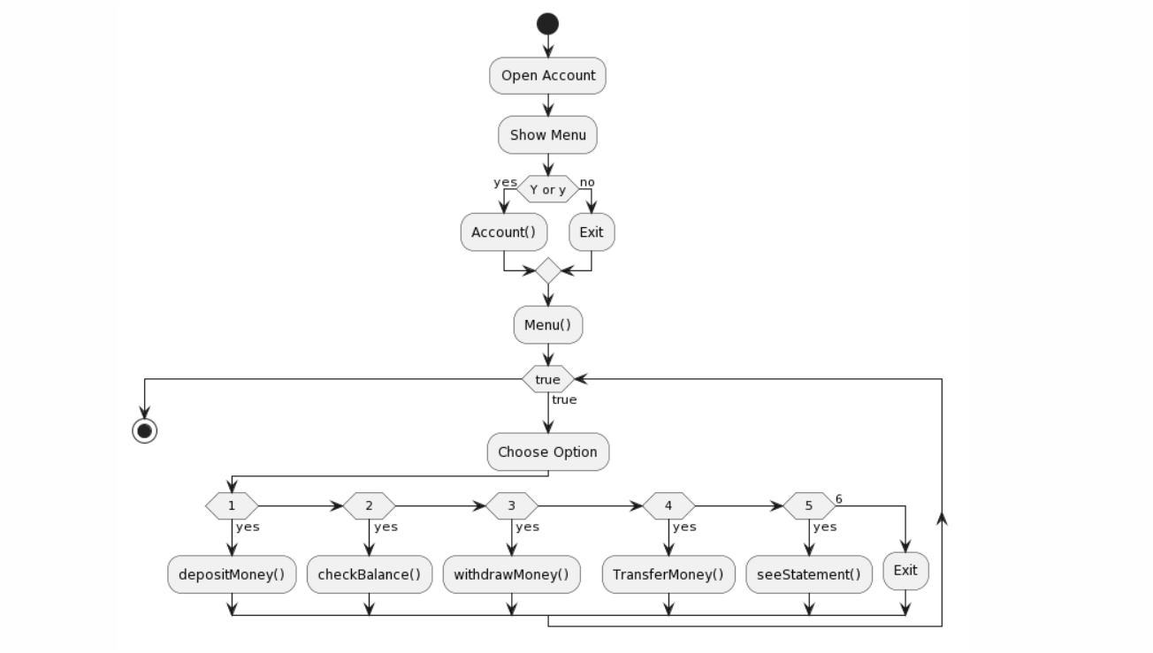

# Development tools

We used C as Programming Language. We used here doubly linked list and store the information in file.

**Sourced Code**

<https://paste.ubuntu.com/p/vsNKrWN9Sn/>

**Output**

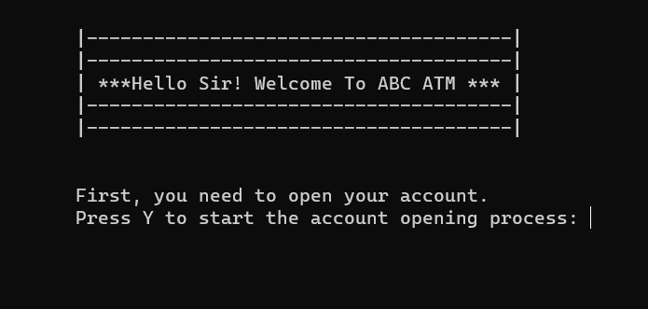

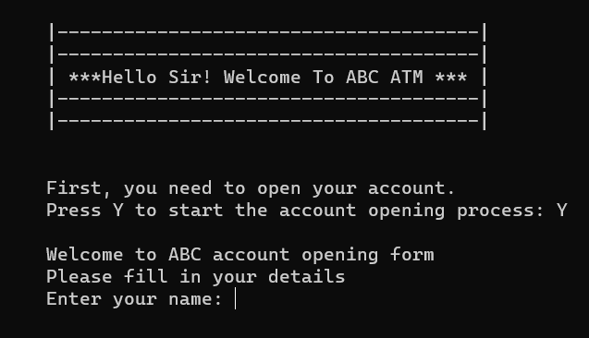

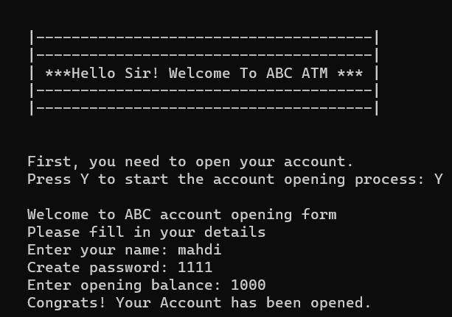

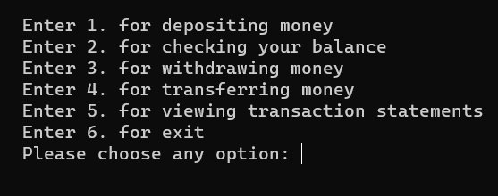

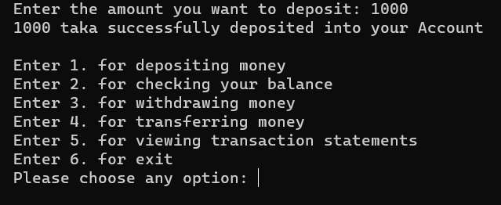

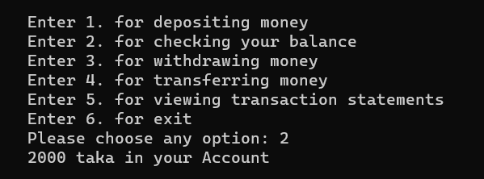

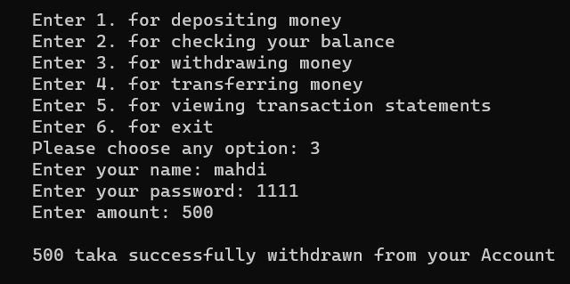

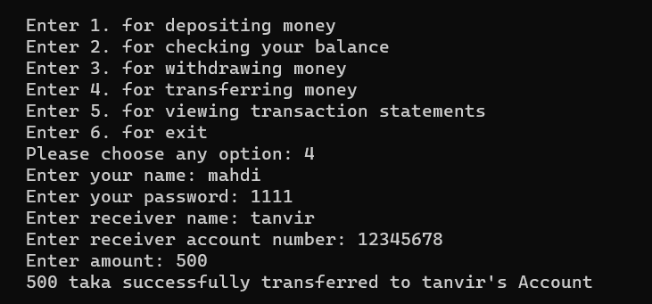

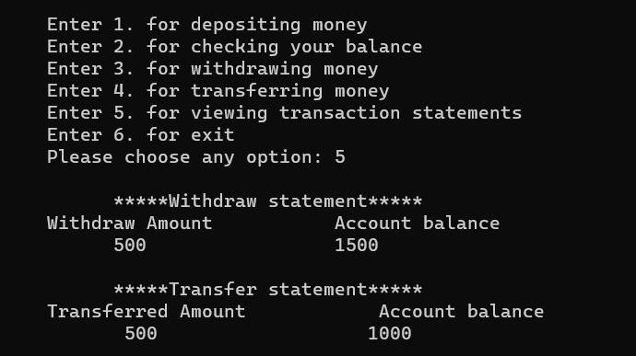

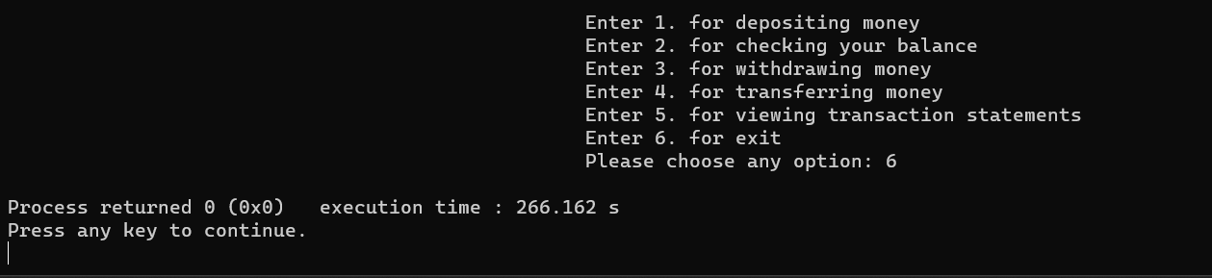

**Future Scope:**

Multi-Platform Support: Extend the application to mobile platforms for wider accessibility.

Biometric Authentication: Implement advanced security measures using biometric authentication methods.

International Transactions: Incorporate features for international fund transfers and currency conversions.

Machine Learning Integration: Enhance security with machine learning algorithms for fraud detection and predictive analysis.

Customer Feedback System: Introduce a feedback mechanism to continuously improve user satisfaction.

Conclusion:

The ABC Bank ATM Management System offers a reliable and easy-to-use solution for banking needs. It enhances user experience, ensures secure transactions, and sets the foundation for an efficient banking system.